# PetFinder API Continued

**1. shelter.find**

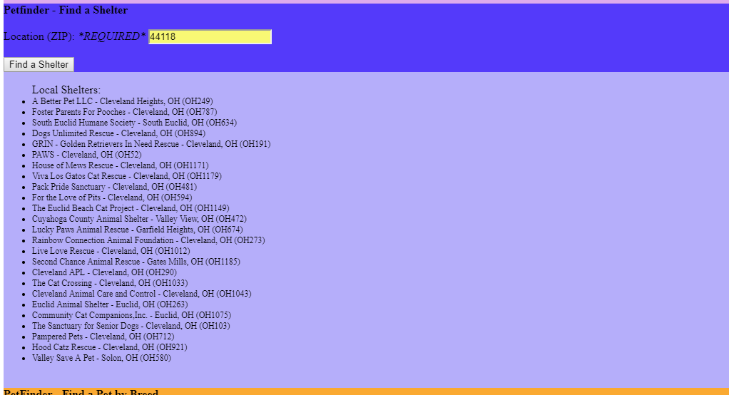

**2. shelter.listByBreed**

shelter.listByBreed wasnot working as expected, as noted. Instead, I made a query to look up a specific breed using pets.find.

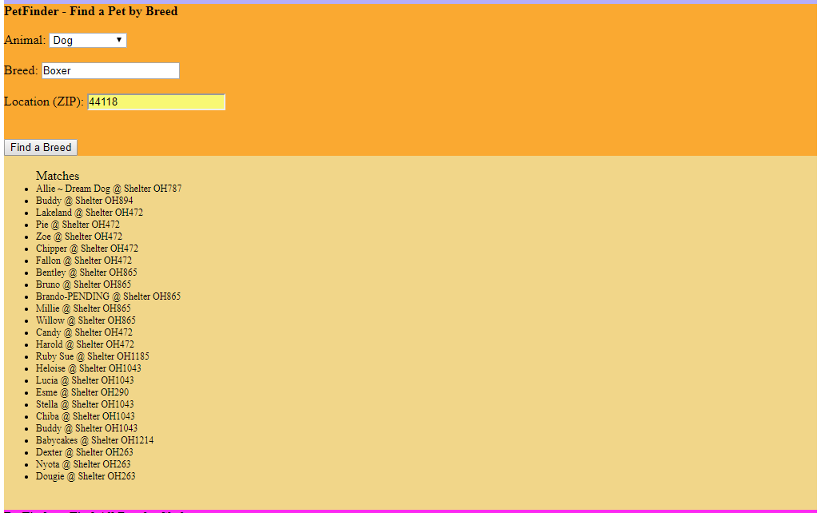

**3. shelter.getPets**

Instructions were somewhat unclear. By entering a Shelter ID, the user can pull the list of available pets at the given shelter, including Species, Breed, Name, and Sex.

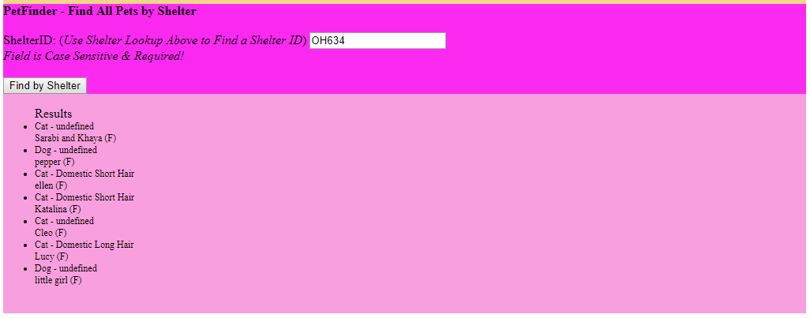

**4. GitHub**